12 December 2025

Dear Families

Year 11 Parent Consultation Evening

I would like to invite you to our Parent Consultation Evening, which will be held on Thursday 8 January 2026 when you can meet your child’s class teachers. This evening is an important time for you to find out how your child is progressing at school and what can be developed further to ensure their success.

All teachers will be available between 4pm - 8pm in the Sports Hall; we strongly recommend you book appointments with as many subject teachers as possible. Feedback in Science will be provided by the lead teacher on behalf of all your child’s teachers – you will only be able to book an appointment with the lead teacher.

SENCO, Amy Rollason, and Safeguarding and Mental Health Lead, Natalie Searle, will be available between 5-7pm. If you would like to book an appointment to discuss your child, please email aatterbury@esherhigh.surrey.sch.uk with your child's name and the reason for the meeting. This will allow sufficient time to prepare for the slot.

Our online booking system can be accessed via the ‘Parents Evening’ area on Edulink: https://www.edulinkone.com/. In order to make bookings you must be logged onto edulink with a parent/guardian account. Full details on how to book appointments are provided at the end of this letter or in this link How Do I Book and Attend a Parents' Evening Slot? - Edulink One Knowledge Hub - Overnet Data Support. The online booking will be open from Monday 15th December 2025 at 6pm until 12pm on Wednesday 7 January 2026.

All staff will be working to 5-minute appointments, please keep this in mind when meeting with staff. Should there be any issues you wish to raise concerning your child’s wellbeing or progress that may take longer to discuss, we recommend you book an appointment for another occasion so that this can be discussed fully.

If for any reason you are unable to attend the evening but would like feedback on your child’s progress, please contact your child’s tutor and they will be able to collate the comments and email these to you.

On arrival at the school grounds please follow the one-way parking system and park at the back of the school and walk to the main entrance of the Sports Hall (front door to the right-hand side of the building) and sign in with our student helpers. Your child will be given a ‘next steps’ sheet to complete during parents’ evening. This will be a place where they can record the key progress areas that their class teachers identify during each appointment.

Yours faithfully
Mr J Howe
Assistant Headteacher

Parents’ Evening Booking: Edulink One

https://www.edulinkone.com/


The parents’ evening area in Edulink One allows parents to see the details about a parents’ evening and to book appointments.

If you do not see the icon on the left this is because you are logged on using a student log on – to make appointments, you must log in as a parent/guardian.

To book your appointments, click anywhere on the parents’ evening event.
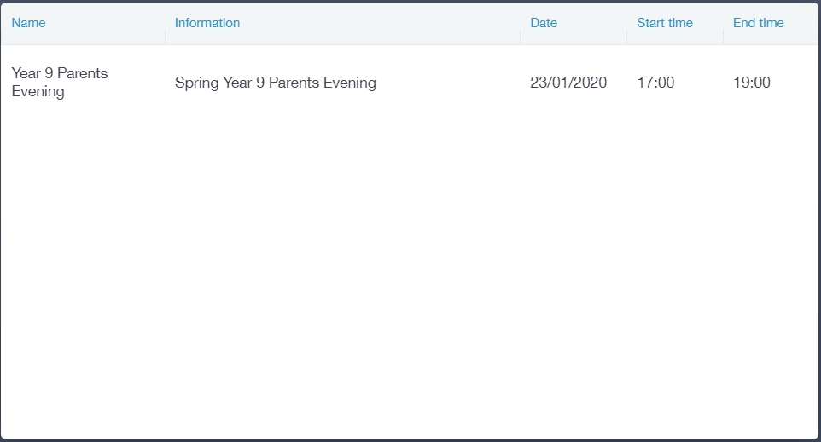

After clicking on the parents’ evening event, a new window will open where you can book appointments with all your child’s teachers. Free spaces appear as white; spaces booked or blocked by someone else appear as grey with a red X; and spaces you have already booked appear in green.
To book an appointment, click on any free white space.
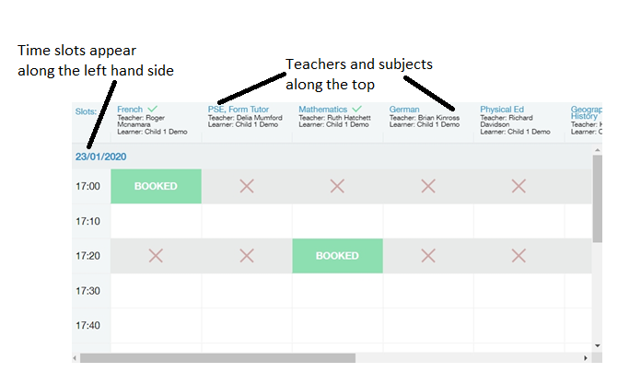

Once you have clicked on a free white space for the subject/ teacher column and the time slot column, then a new book slot window opens. It details the date and time of the booking slot, the subject you are booking and the child you are booking for. At this time, you can also add a comment, for example, if there is something in particular you would like to discuss with the teacher.

Click on the green Book button to book. Your bookings will appear when you click on the event.

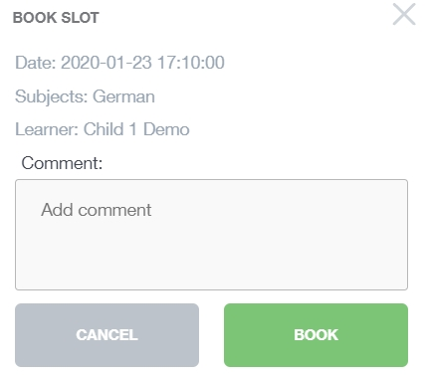

Printing and Emailing the Parents Evening Appointments
You can also print your bookings. Edulink One can also email (using the Email button) a copy of the Parents’ Evening bookings if your school has enabled these settings.

To print your bookings, click on the Print button at the top of your booking screen. A list of your appointments will be generated for you to print.


