COMPETITION
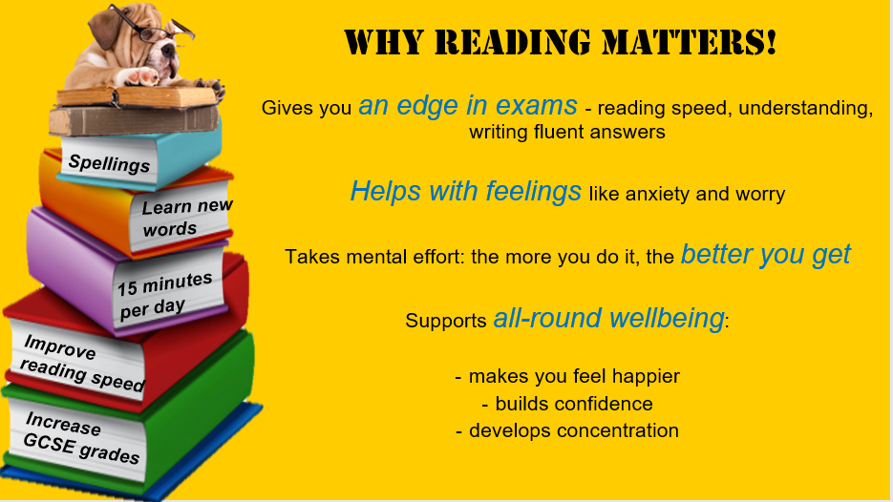 | Read the short stories or any novel over the summer holidays. For each story or book read, complete one of the activities and submit it by 5pm on Friday 4th September 2020 to MS Bosley ebosley@esherhigh.surrey.sch.uk  1st, 2nd and 3rd Prizes will be awarded shortly after to each year group for effort made to keep up with your reading skills during the summer holidays.

Name: ___________________Tutor Name: ___________________

During Reading: Questioning

Based on what you already know about the subject, did it match up to your expectations? Did you find out anything interesting or new?
______________________________________________________________________________________________________________________________________________________________________________________________________________________________________________________________________________________________________________________________________________________________________________________________________

During Reading: Questioning

Create your own questions based on the parts of the book you have read so far.
Q1. ______________________________________________________________
Q2. ______________________________________________________________
Q3. ______________________________________________________________
Q4. ______________________________________________________________
Q5. ______________________________________________________________

Why not team up with a friend reading the same book and see if you can have a go at each other’s questions - remember to discuss the answers.

During Reading: Adjectives

Pick a page you have read so far in the book. Looking at this page, make a list of the adjectives the author uses to describe things. Choose three of the words and write your own sentences using those words.

All the Adjectives

During Reading: Tweet

Imagine you were the main character in your reading book. Can you write a short tweet to another character letting them know what is going on?

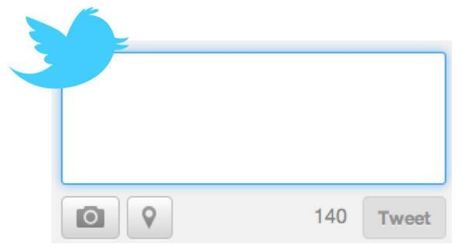 | _____________________________  _____________________________  _____________________________  _____________________________  _____________________________  _____________________________  _____________________________

After Reading: Summarise

Can you summarise the whole novel in 30 words or less?

After Reading: Summarise

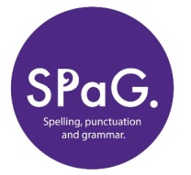
Thinking about the story, can you identify the main ideas within a comic strip? Think about what points are most important to the story.
Draw in these boxes

*1. | 2. | 3.
4. | 5. | 6.

*Write the short summary in the numbered boxes and in correct time order as the event happened.

After Reading: Thoughts?

Looking back at what you predicted this book would be about, are you surprised by any parts? Was it what you expected? What was different?
______________________________________________________________________________________________________________________________________________________________________________________________________________________________________________________________________________________________________________________________________________________________________________________________________

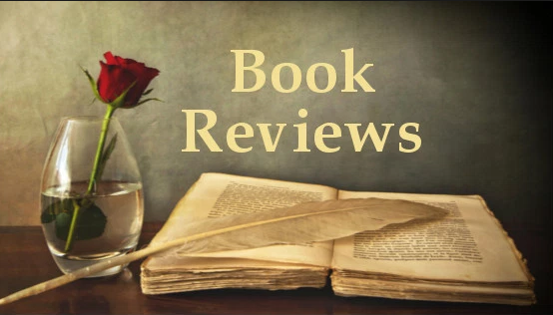
After Reading: Book Review

Prior Knowledge- do you need any background knowledge of the book before reading? If so what would help?

Summarise the book. Try and advertise the book- why would someone want to read it?

Did you have a favourite part? Why?

Who is this book suitable for? (Think about the themes of the book, vocabulary etc.)

